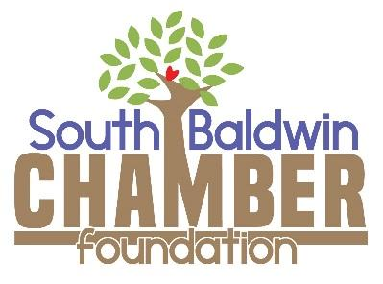

Dear Partner in Education:

Thank you for partnering with the South Baldwin Chamber Foundation to enrich education, develop leadership and better our community. Your donation of $________ will help make a difference for students in our Foley area schools.

Our Student & Teacher Grants program provides schools with resources needed to enhance the learning environment. Programs like Bridges to Success, Junior Ambassadors, and Leader In Me engage students in activities that help them succeed in school and help prepare them for life’s challenges after graduation. The Chamber Foundation advocates for students by securing grants and partners for the advancement of significant school initiatives. For example, new STEM-focused instruction, such as VEX Robotics, is helping our students strengthen knowledge and skills in Science, Technology, Engineering and Math with an exciting, hands-on approach to learning.

On behalf of our of schools and the South Baldwin Chamber Foundation Board of Directors, thank you for helping us work toward our vision for all students to graduate as world class students who are college and career ready. We look forward to working with you to make that vision a reality.

Sincerely,
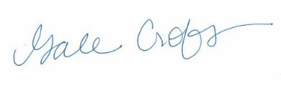
Gale Croft
Executive Director

Tax ID# 20-0287247. No goods or services were provided in exchange of the gift; therefore, the full amount of your gift is tax deductible. Please retain this letter as verification of the above donation in compliance with the IRS regulations.

